Performance testing Developers Guide

Contents
Performance testing Tools 2
Writing web performance tests 3
Creating Tests 4
Guidelines on Load tests 8
Guidelines on Standalone tests 9
Guidelines on Web tests 10
Guidelines on Data Sources 10
Results 10
Performance Tests Plugins 10
Data Preparation & Preparation tooling 11

Performance testing Tools
The following tools are to be used when creating performance and web tests:
- Visual Studio Enterprise
- Internet Explorer
- User Generated Plugins
Writing web performance tests
Currently our solution is broken down into main sections
- LoadTests
  - Load tests that run through specific scenarios
  - A Load test is built with multiple Standalone web tests
- StandaloneWebTests
  - Web tests are end to end tests.
    - They have logins
    - Set up parameterised data
    - Can map to Data sources when needed.
  - Made up from a number of smaller web performance tests
- WebTests
  - Web tests are tests that perform a given function i.e. get a customer, create a means
  - These cannot be run individually
In each of the above section we further break down the tests in to their cluster areas. Currently you will see areas that cover the following sections: Activation Support, Appointment, Calendar, Claims, Debt, Means Assessment, Officer, and Task. (This is not the full list)
Creating Tests
Tests are created through Visual Studio Enterprise edition.
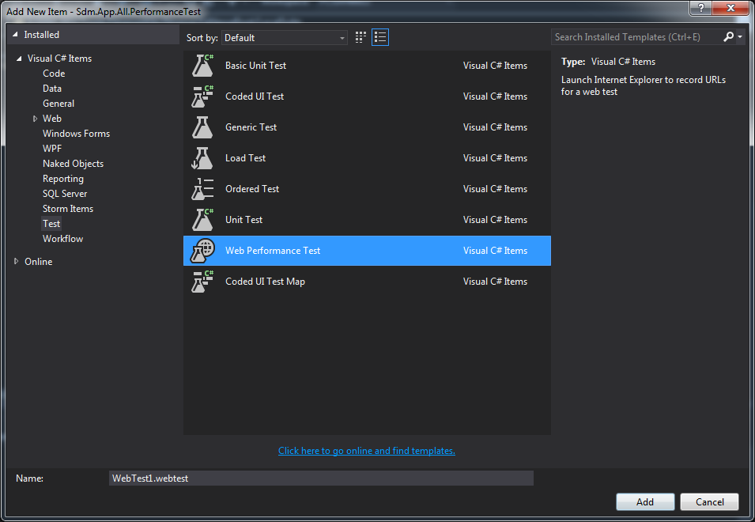
Once a test is created, Visual Studio Enables the Recorder to recored the test. Here we are given an option for any plugins to run. In our case, if you have set up any Plugins, you can deciede to disable and enable them.
Please see the section below for details of how to Set up Plugins.
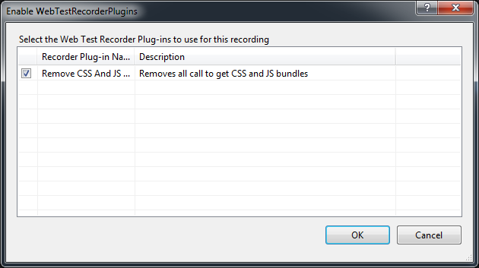
Once you click on Ok you the system will open up a web browser. If you get the following error
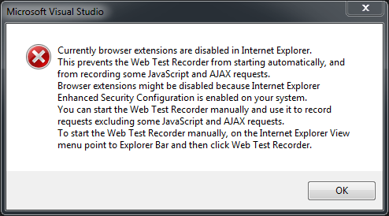
The above error is caused by third party browser extensions
You can fix this error by enabling the following:
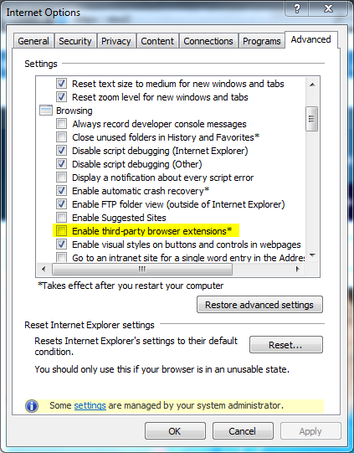
Once you have this enabled you can then proceed to recording your test:
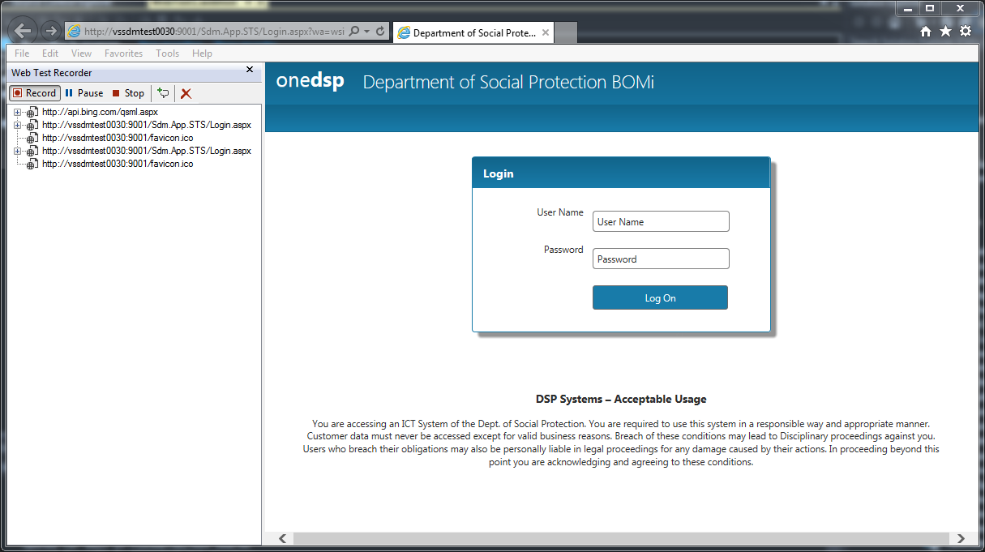
You will see the steps on the left hand side; some of these steps can be deleted once we finish recording the test as they are not needed. A good policy to follow is to ensure that you record the tests with the develop tools open (F12, from within the browser) this will ensure that you only record what is needed.
Once the test has been created it is up to the developer to ensure that the test is:
- Re-runnable
- Has data prepared for it ( When using finders ensure that the finder brings back results )
- Tests should have some type of data preparation it is not enough to rely on data currently in the database.
- Ensure that the test does not query or run the same data over and over again. ( SQL can cache queries and improve performance)
- Ensure Data is consumed from a data source, the preferred option is to use a SQL query to populate a test table
  - Tables should read something like : test_{BUSINESS_AREA}_{OBJECT DESCRIPTION}
    - i.e. test_Employment_Support_Customers holds information that we will use for customer who are set up for employment support.
  - This allows us to keep track of test and ensure all tests are written to our standards.
- Ensure data that covers new areas are bulked up with data so that they will reflect what data will be in live in 12 months.
- Data should be re runnable and work when used in to the future
- The generated test should be broken up in to sections whenever possible, this allows for reuse of test components.

Guidelines on Load tests
- Mix of standalone tests that cover the area that is being tested.
- Test mix to be based on (expected) usage statistics
- Higher used action should be tested more.
- Need to model application usage and expected usage
- Tests must be re-runnable once data prep is re-run.
- Test data/volumes must be similar to Live
- Test should have either a ramp up phase or be of constant load
- Tests should run for a given amount of time, an hour or part thereof gives us ample time to look at performance

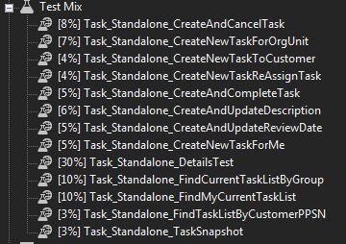

Guidelines on Standalone tests
- Individual Performance tests should be planned in accordance to expected usage of the project/cluster area
- Tests should include all key user stories for the area that they are being developed for.
- Standalone tests are the tests that get run in the load tests they have to be made up from the web tests
- Test neds to include a login test
  - Test needs to web test that sets up global parameters
  - Test needs to run other test.
- Ensure parameters can be passed from test to test.

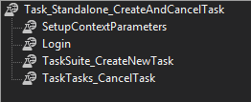

Guidelines on Web tests
- Small pieces of work, which should only make a few calls to the server
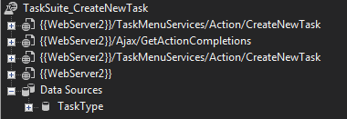
- Contain the links to data sources
- Contain parameterised requests

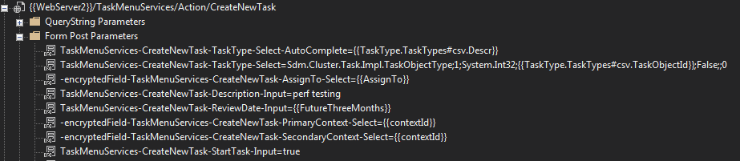

Guidelines on Data Sources
- Data should be consumed from a database data source where possible
- Test Tables should be introduced into the data base via the data preparation tool, these tables will be consumed by web tests.
- Tables should use the following naming convention
- test_{BUSINESS_AREA}_{OBJECT DESCRIPTION}
- i.e. test_Employment_Support_Customers holds information that we will use for customer who are set up for employment support.
- This allows us to keep track of test and ensure all tests are written to our standards.
- New Database Tables should be bulked up with data so that the reflect what Live environment will look like in 12 months

Results
- Baseline results for all tests are required, these will be used by the CT team going forward
- They will be monitored to ensure that performance does not change.
- Key Performance indicators need to be decided
- End user response time
- Server stats : CPU, memory, latency (Need input from Prod Support )
- Database stats :CPU, memory, latency ( more DBA input)

Performance Tests Plugins
- Plugin is found in the following solution Sdm.App.LoadTestUtils

To get the WebTestRecorderPlugin working you must do the following:
- Build the Utils project.
- Copy the DLL to the following locations :
- C:\Program Files\Microsoft Visual Studio 12.0\Common7\IDE\PrivateAssemblies\WebTestPlugins
- C:\Users\XXXXX\Documents\Visual Studio 2013\WebTestPlugins

Data Preparation & Preparation tooling
- Data preparation needs to take place for a number of reason :
  - Tests need data ensure that they are re run able as we cannot rely on data being in the database.
  - It ensures that when we run a test we are running a test for a similar situation every time, this allows us to trust the results more.
  - For new tables, it allows us to bulk out this data to ensure that we are testing with volumes that will be relevant to the live system.

- In order for us to be able to run the data preparation tests we have developed a tool that will allow us to run scripts into the database. Below is a guide to how to use this tool correctly :
- The Data preparation tool is located within the same solution as the performance tests.
- To run the tool simply press f5 as it is the default project and will build and run.
- The application is a simple windows form application, which allows you to choose the database you wish to prep and run certain scripts on.
- The scripts are broken up into areas.
- To add and remove data bases to the application you have to edit the databases.xml, here you simple have to add in the server for the database to get it added.

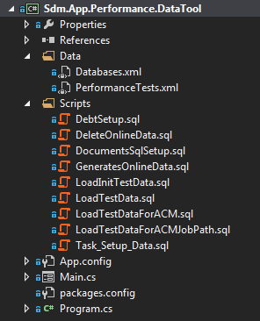

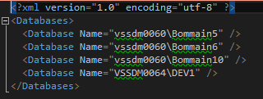

- To add a script to the project. You have to add the script to the /Scripts folder and then make a change in the PerformanceTests.xml file
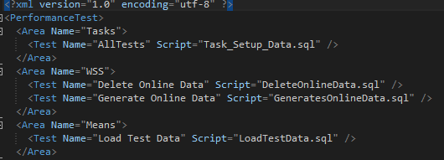
- Here you add in an Area and the name of the script and the file name of the script.
- Once this is done you will be able to run your script from the app.

